In TOOLS, go to BOARD and go to NodeMCU 1.0 (ESP-12E Module)

//we will be using this one for the wifi module

**Door Sensor:**

THIS IS FOR CLOSED DOOR: 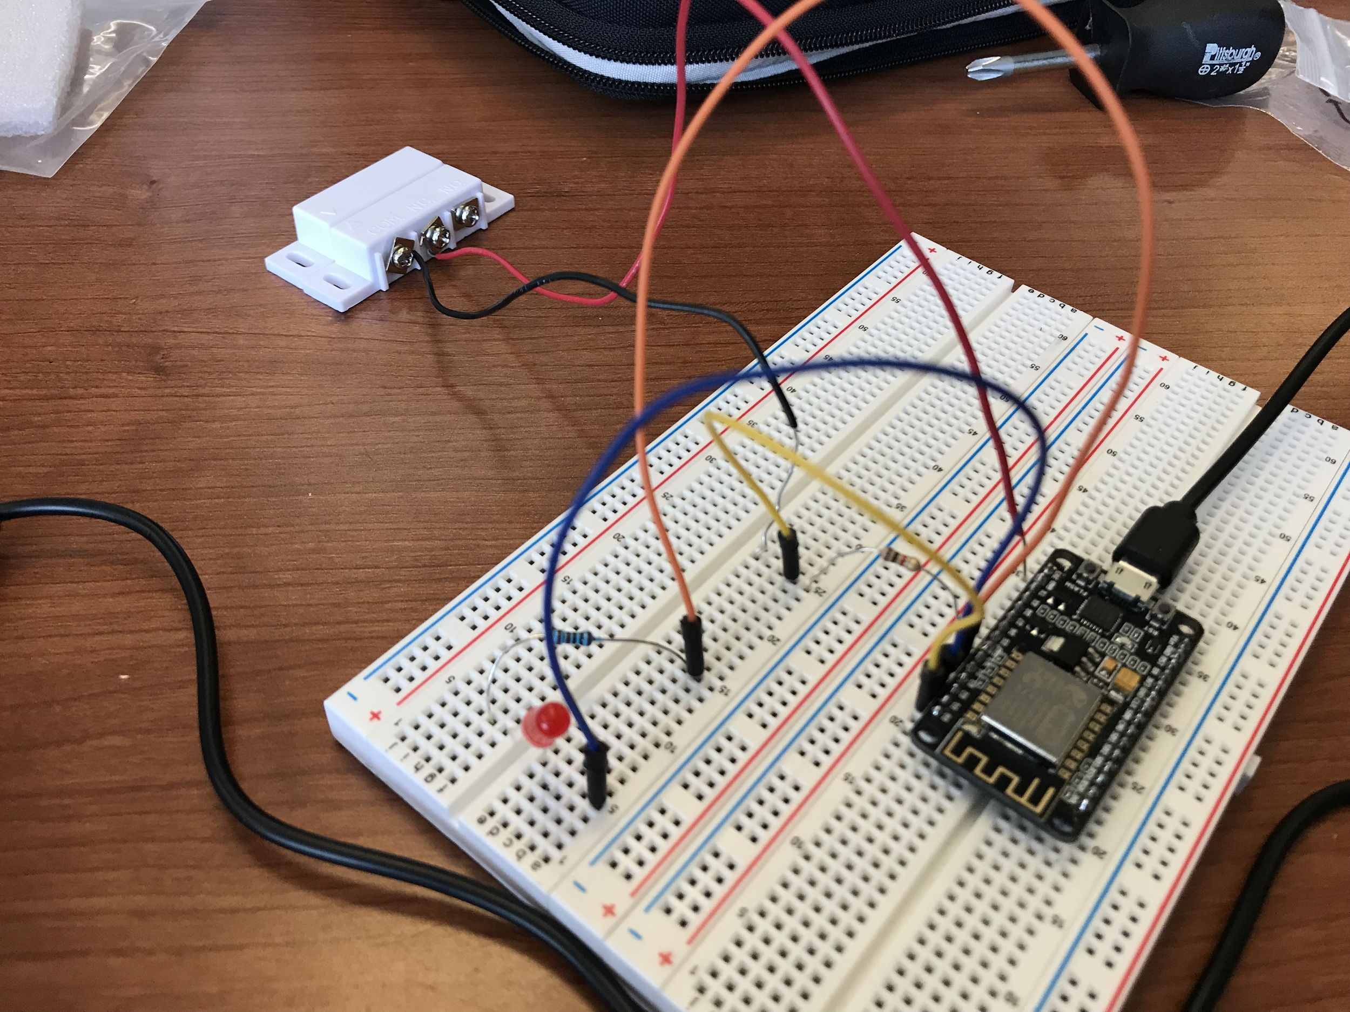

THIS IS FOR OPEN DOOR: 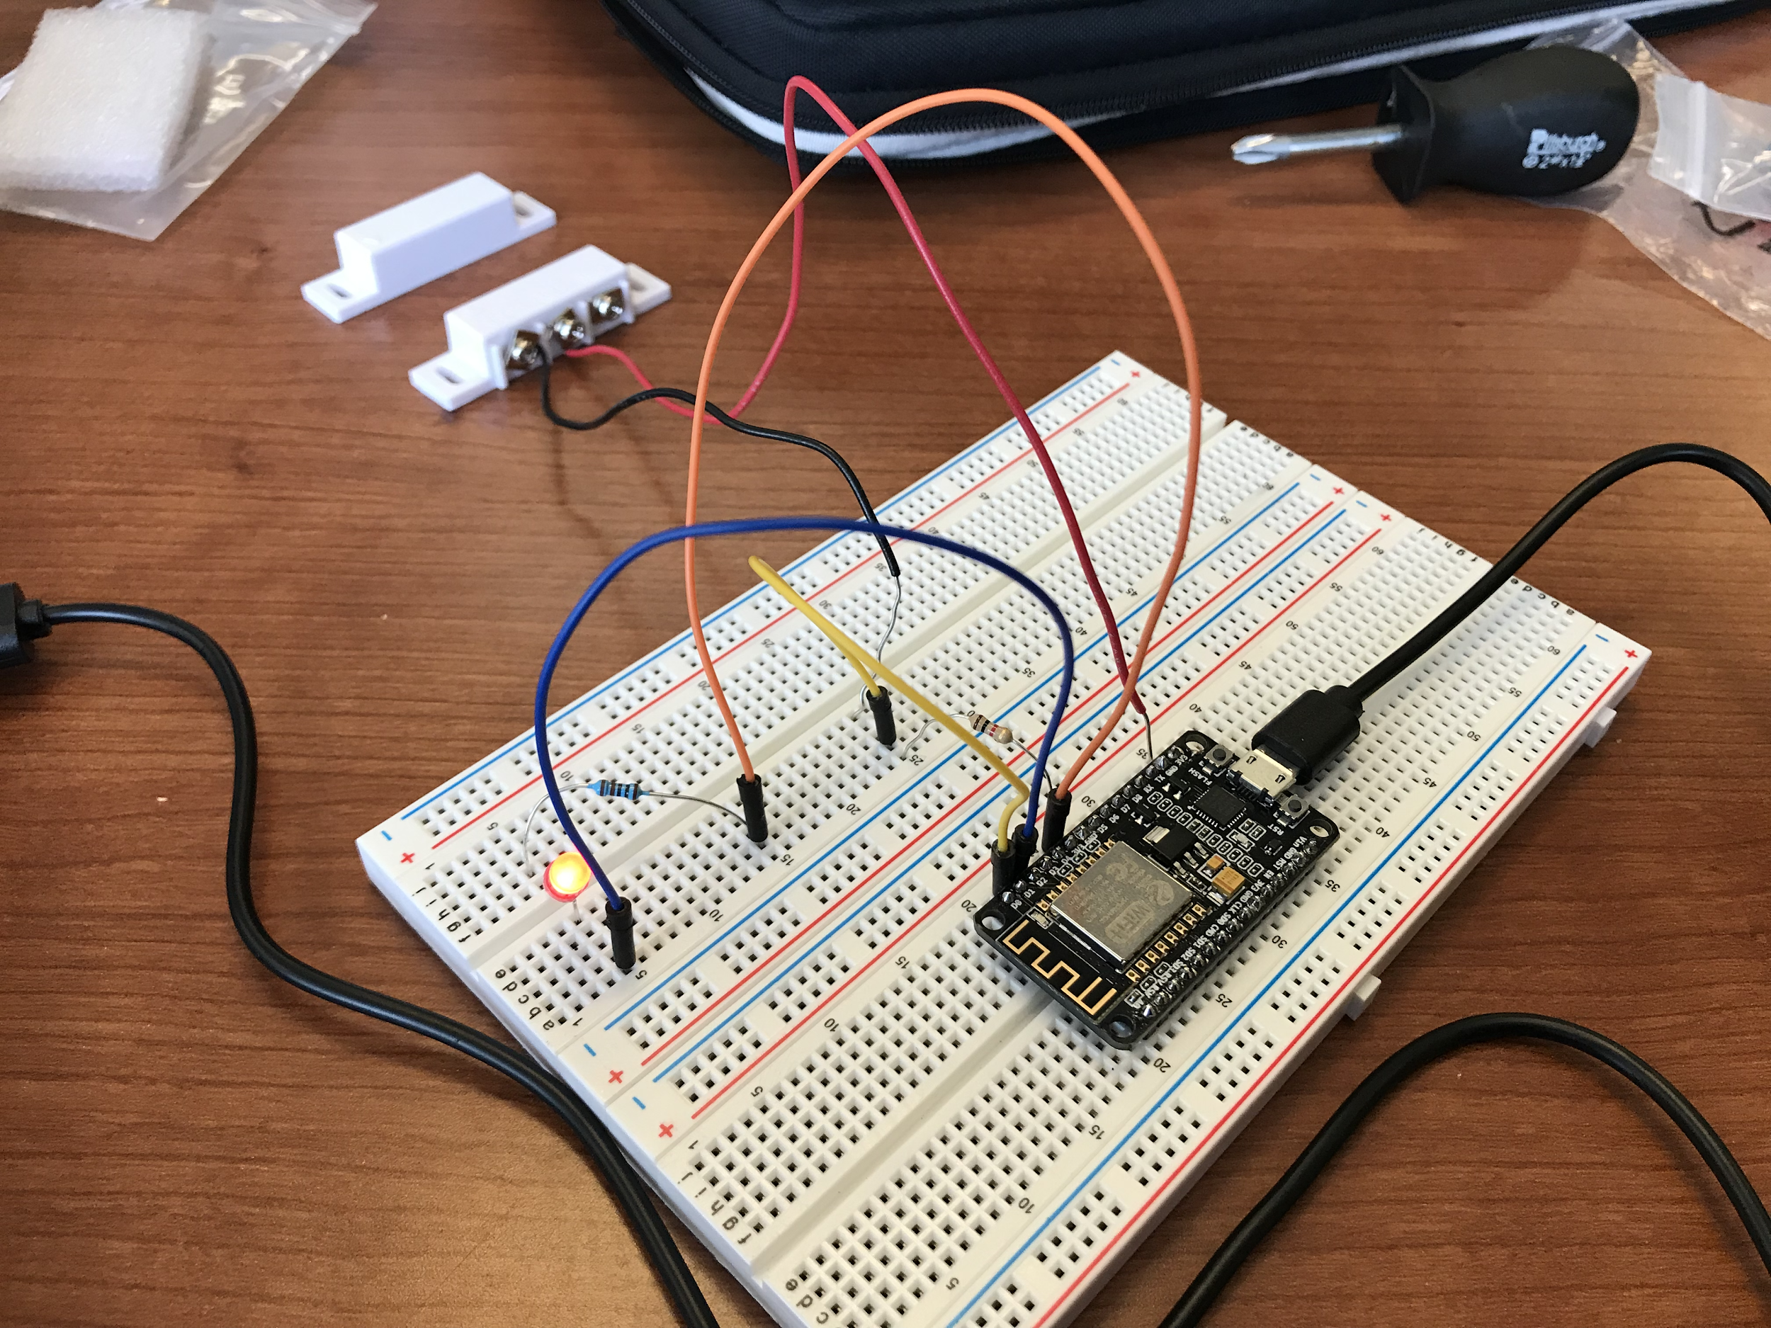

**Notes:**

For Door Sensor, must connect the terminals COM and N.C. to the terminals on the NodeMCU D1 and 3.3 V.

The 3.3 V Terminal is connected to the N.C. terminal and the COM Terminal is connected to the D1 Terminal through a 1k-Ohm resistor.

NEW SET UP:  
